SummerLands Pilot Project
Does your community group have an idea for a temporary pop-up park, container garden, community event space or art installation?

Ramsey County is making some land available for seasonal community use. Apply to manage a piece of land from May 2020 to October 2020.

Apply online or download a paper application at: ramseycounty.us/SummerLands

Applications must be received by Thursday, April 30, 2020.
- Email applications to Mee.Cheng@ramseycounty.us OR
- Drop off applications in Suite 250 in the Ramsey County Courthouse (15 W. Kellogg Blvd, St. Paul, MN 55102). This is the same building as St. Paul City Hall.

REQUIREMENTS
- Seasonal use, all uses must end before October 31 and land must be returned to previous state.
- Application needs to be from or sponsored by a non-profit organization.
- Non-profits with liability insurance over $1 million are eligible to apply
- Have a plan and funding. Ramsey County is not offering funding, just access to the land.
- One-time use is discouraged.
- All land is smoke-free, tobacco-free, drug-free and e-cig free.
- No consumption of alcohol is permitted on the land.
- The land must remain open to the public.
- Must conform with all city ordinances including noise, sound amplification, etc.
- Must keep site up to city code, this includes grass length, debris, and overall cleanliness.
- Land must be free of hate speech, religious speech (separation of church and state), and strong political statements.

ACCEPTABLE USES
- Temporary community event space
  - Performance space
  - Meeting space
  - Market space
  - Festival space
- Temporary park or greenspace
  - Seating/rest areas
  - Off-the-ground compost container
  - Exercise space
  - Yard games
- Temporary art installations
- Temporary container garden
  - Sites do not have water sources
  - No gardening in the soil on the eligible land
  - Containers must be above ground and soil from selected land cannot be used
  - Additional gardening resources are on our website: ramseycounty.us/SummerLands

AVAILABLE LAND
There are land available for temporary use.

Smith Avenue at Curtice
778 Smith Avenue on Saint Paul’s Westside is a piece of tax-forfeited land that is 8,755 ft2. The land is owned by the State of Minnesota and is managed by Ramsey County until it is put back on the private market. The land has probable soil contamination due to its former use as an autobody shop. The land can be accessed on Smith Avenue or Curtice Street. Water access is not available on this site.

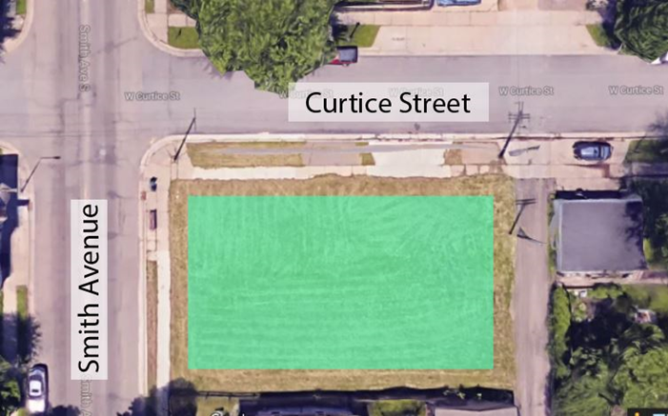

Pierce Butler Route at Avon Street
This piece of land is owned and managed by Ramsey County’s Public Works and is road right-of-way. The land is in Saint Paul’s Frogtown neighborhood and can be accessed on Avon Street. Water access is not available on this site. The green squares are recommended areas because they are relatively flat. If you are interested in other areas on this site, please contact Mee Cheng.

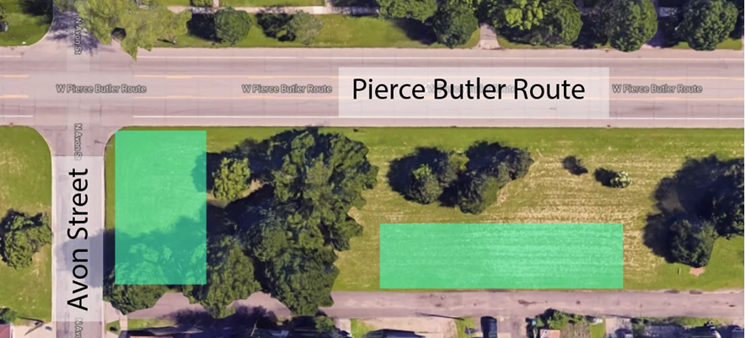

Pierce Butler Route at Grotto Street
This piece of land is owned and managed by Ramsey County and is road right-of-way. The land is in Saint Paul’s Frogtown neighborhood and can be accessed on Grotto Street. Water access is not available on this site. The green squares are recommended areas because they are relatively flat. If you are interested in other areas on this site, please contact Mee Cheng.

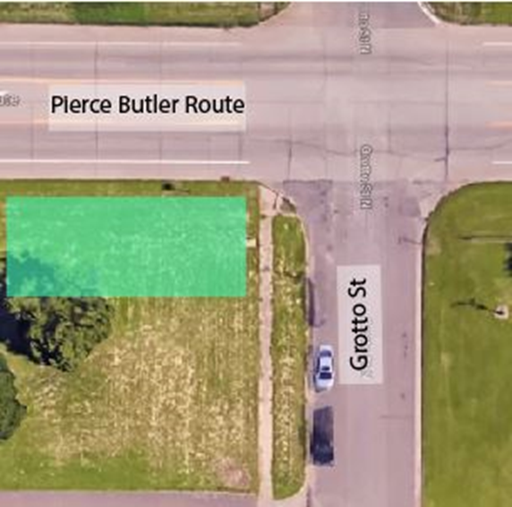
REVIEW TEAM
Applications will be reviewed by a cross-department team with members from the following departments:
- Public Health
- Property Management
- Property Tax Records and Election Services
- Public Works
- Community and Economic Development
- County Manager’s Office
- County Attorney’s Office
- Risk Management

CRITERIA TO EVALUATE APPLICATIONS
The review team will use the following criteria to evaluate applications:
Total possible points: 65
- The sponsoring non-profit organization is based in the surrounding neighborhood (5 points possible)
  - Non-profit is located in/headquartered in community (5 points)
  - Non-Profit isn’t located in, but describes strong relationships with surrounding community (1-4 points)
  - Non-profit is not located in neighborhood and doesn’t describe strong relationships with surrounding community (0 points)

- How clear, realistic and actionable is the applicants proposed plan? (20 points possible)
  - The proposed plan falls under the list of acceptable uses and can meet all requirements, such as maintenance and ending the use by the end of October (20 points)
  - The proposed plan falls under the list of acceptable uses, but may have a hard time meeting all requirements. May need additional resources to be successful. (8-15 points)
  - The plan is not considered an acceptable use and may have a hard time meeting all requirements (0 points)

- Group includes member who live or work in the surrounding neighborhood or describe strong relationships with surrounding community (15 points possible)
  - All or almost all members live or work in the surrounding neighborhood (13-15 points)
  - Some members live in the surrounding neighborhood or describe strong existing relationship with surrounding community (7-12 points)
  - Group members do not live or work in neighborhood, and do not describe strong relationships with the surrounding community (0-6 points)

- Group plans to actively use land (10 points possible)
  - Frequently or very infrequently (Daily, weekly or bi-weekly) (10 points)
  - Occasionally or infrequently (Once per month) (5 points)
  - Very infrequently (Less than once per month, or single event) (0-2 points)

- Plan for Communications (10 points possible)
  - Robust. Could include many, diverse mediums and audiences, such as other non-profits, other community coalitions, culturally-specific groups that reflect the community, nearby residents, schools, social media, local newspapers, radio, other media outlets. (10 points)

  - Traditional engagement/communication plan. Plans to reach out to existing community organizations, their existing membership and use social media. Less focused on multiple approaches. (5-9 points)

  - Weak communication plan. Offers little detail on how they will reach out to the surrounding community and nearby residents. (0-4 points)

- Will the land be open to all interested residents? Not everyone may be able to participate in the planned program or event, but the land should remain open to all. (5 points possible)
  - Yes, the land is open for all interested participants (5 points)
  - No, the land will be closed off to the public (0 Points)

For additional information, visit ramseycounty.us/SummerLands or contact:

Mee Cheng
Phone: 651-266-9200
Email: Mee.Cheng@ramseycounty.us

SummerLands Application

Applications must be received by Friday, April 30, 2020.
- Email applications to Mee.Cheng@ramseycounty.us OR
- Drop off applications in Suite 250 in the Ramsey County Courthouse (15 W. Kellogg Blvd, St. Paul, MN 55102). This is the same building as St. Paul City Hall.

Are you a non-profit sponsoring your proposed activity? (Non-profit organizations with liability insurance of $1 million are eligible to apply. Please attach organization’s W-9 with your application.)

Name of Non-profit organization:

Address of non-profit organization:

Non-profit contact person:

Non-profit contact information (phone or email):

Contact Person for Application (if different from above):

Email address of contact person (if different from above):

Which piece of land are you applying for? (You may apply for more than one):
☐ Smith Avenue at Curtice
☐ Pierce Butler at Avon Street
☐ Pierce Butler at Grotto Street

What does your group propose to do with this piece of land? Please describe your proposed program for seasonal use (May through October 31). Please consult the list of acceptable uses and details on the available land.

How often will your group use this piece of land? (For example: weekly events; daily with a container garden, pop-up park, or art park) One-time use is discouraged.

Describe the membership of your group or organization. Do they live and work in the surrounding community? Do they have existing relationships with the surrounding community?

Is the proposed program for this piece of land open to all interested residents?

Describe or list how you will communicate, engage and advertise your proposed program to the surrounding community, nearby neighbors and other community organizations. Also, describe or list who you plan to communicate and engage with. (We encourage communication with neighbors, community organizations, culturally-specific groups that reflect the surrounding community, schools, businesses, local media and on social media.)

Applications must be received by Friday, April 3, 2020.
- Email applications to Mee.Cheng@ramseycounty.us OR
- Drop off applications in Suite 250 in the Ramsey County Courthouse (15 W. Kellogg Blvd, St. Paul, MN 55102). This is the same building as the St. Paul City Hall.

